**LockedMe – Virtual Key for Repositories**

This document contains sections for:

* Sprint planning and Task completion
* Core concepts used in project
* Flow of the Application.
* Demonstrating the product capabilities, appearance, and user interactions.
* Unique Selling Points of the Application
* Conclusions

The code for this project is hosted at <https://github.com/allen9805/LockedMe>.

The project is developed by Divyanshu Kumar.

## Sprints planning and Task completion

The project is planned to be completed in 1 sprint. Tasks assumed to be completed in the sprint are:

* Creating the flow of the application
* Initializing git repository to track changes as development progresses.
* Writing the Java program to fulfill the requirements of the project.
* Testing the Java program with different kinds of User input
* Pushing code to GitHub.
* Creating this specification document highlighting application capabilities, appearance, and user interactions.

## Core concepts used in project

Collections framework, File Handling, Sorting, Flow Control, Recursion, Exception Handling, Streams API

## Flow of the Application

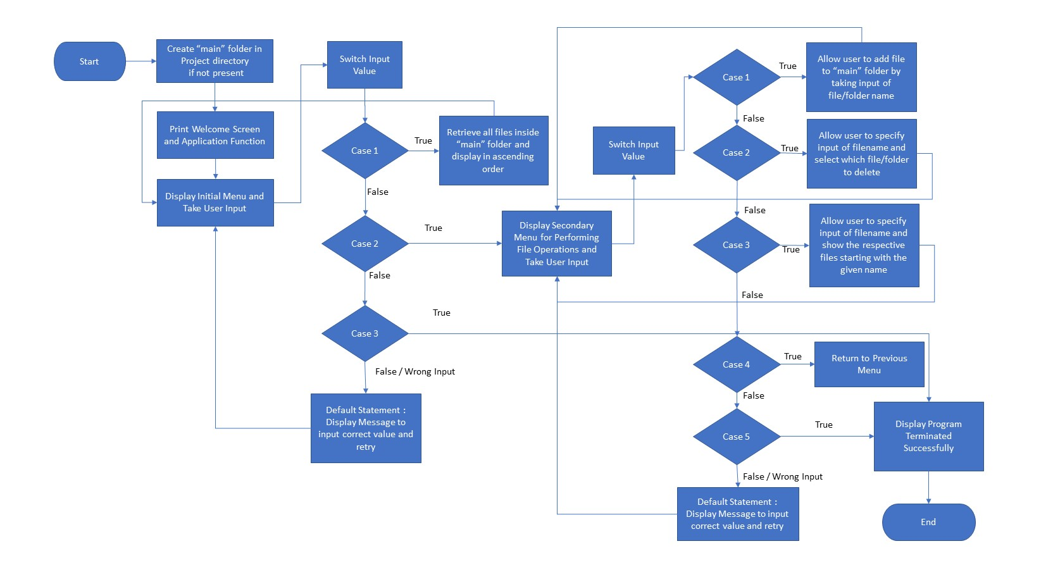



## Demonstrating the product capabilities, appearance, and user interactions

To demonstrate the product capabilities, below are the sub-sections configured to highlight appearance and user interactions for the project:

1. Creating the project in Eclipse
2. Writing a program in Java for the entry point of the application (**LockedMeMain.java**)
3. Writing a program in Java to display Menu options available for the user (**MenuOptions.java**)
4. Writing a program in Java to handle Menu options selected by user (**HandleOptions.java**)
5. Writing a program in Java to perform the File operations as specified by user (**FileOperations.java**)
6. Pushing the code to GitHub repository

## **Step 1:** Creating a new project in Eclipse

* Open Eclipse
* Go to File -> New -> Project -> Java Project -> Next.
* Type in any project name and click on “Finish.”
* Select your project and go to File -> New -> Class.
* Enter **LockedMeMain** in any class name, check the checkbox “public static void main(String[] args)”, and click on “Finish.”

## **Step 2:** Writing a program in Java for the entry point of the application (**LockedMeMain.java**)

**package** com.lockedme;

**public** **class** LockedMeMain {

**public** **static** **void** main(String[] args) {

// Create "main" folder if not present in current folder structure

FileOperations.*createMainFolderIfNotPresent*("main");

MenuOptions.*printWelcomeScreen*("LockedMe", "Divyanshu Kumar");

HandleOptions.*handleWelcomeScreenInput*();

}

}

## **Step 3:** Writing a program in Java to display Menu options available for the user (**MenuOptions.java**)

* Select your project and go to File -> New -> Class.
* Enter **MenuOptions** in class name and click on “Finish.”
* **MenuOptions** consists methods for -:
  1. Displaying Welcome Screen
  2. Displaying Initial Menu
  3. Displaying Secondary Menu for File Operations available

**Step 3.1:** Writing method to display Welcome Screen

**public** **static** **void** printWelcomeScreen(String appName, String developerName) {

String companyDetails = String.*format*("*****************************************************\n"

+ "** Welcome to %s.com. \n" + "** This application was developed by %s.\n"

+ "*****************************************************\n", appName, developerName);

String appFunction = "You can use this application to :-\n"

+ "• Retrieve all file names in the \"main\" folder\n"

+ "• Search, add, or delete files in \"main\" folder.\n"

+ "\n**Please be careful to ensure the correct filename is provided for searching or deleting files.**\n";

System.***out***.println(companyDetails);

System.***out***.println(appFunction);

}

**Output:**

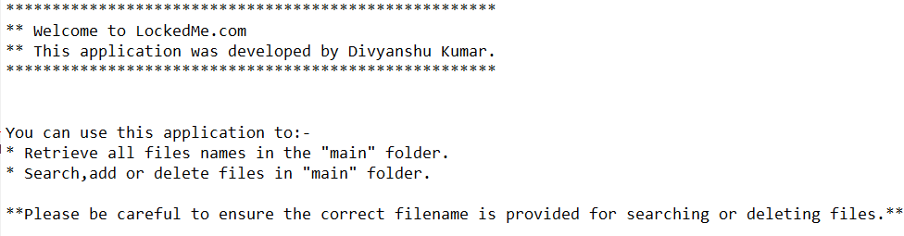

**Step 3.2:** Writing method to display Initial Menu

**public** **static** **void** displayMenu() {

String menu = "\n\n****** Select any option number from below and press Enter ******\n\n"

+ "1) Retrieve all files inside \"main\" folder\n" + "2) Display menu for File operations\n"

+ "3) Exit program\n";

System.***out***.println(menu);

}

**Output:**

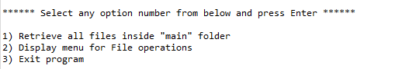

**Step 3.3:** Writing method to display Secondary Menu for File Operations

**public** **static** **void** displayFileMenuOptions() {

String fileMenu = "\n\n****** Select any option number from below and press Enter ******\n\n"

+ "1) Add a file to \"main\" folder\n" + "2) Delete a file from \"main\" folder\n"

+ "3) Search for a file from \"main\" folder\n" + "4) Show Previous Menu\n" + "5) Exit program\n";

System.***out***.println(fileMenu);

}

**Output:**

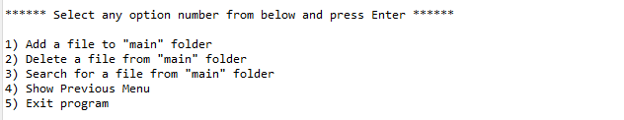

## **Step 4:** Writing a program in Java to handle Menu options selected by user (**HandleOptions.java**)

* Select your project and go to File -> New -> Class.
* Enter **HandleOptions** in class name and click on “Finish.”
* **HandleOptions** consists methods for -:
  1. Handling input selected by user in initial Menu
  2. Handling input selected by user in secondary Menu for File Operations

**Step 4.1:** Writing method to handle user input in initial Menu

**public** **static** **void** handleWelcomeScreenInput() {

**boolean** running = **true**;

Scanner sc = **new** Scanner(System.***in***);

**do** {

**try** {

MenuOptions.*displayMenu*();

**int** input = sc.nextInt();

**switch** (input) {

**case** 1:

FileOperations.*displayAllFiles*("main");

**break**;

**case** 2:

HandleOptions.*handleFileMenuOptions*();

**break**;

**case** 3:

System.***out***.println("Program exited successfully.");

running = **false**;

sc.close();

System.*exit*(0);

**break**;

**default**:

System.***out***.println("Please select a valid option from above.");

}

} **catch** (Exception e) {

System.***out***.println(e.getClass().getName());

*handleWelcomeScreenInput*();

}

} **while** (running == **true**);

}

**Output:**

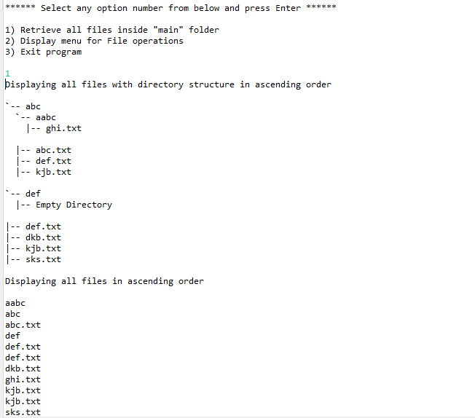

**Step 4.2:** Writing method to handle user input in Secondary Menu for File Operations

**public** **static** **void** handleFileMenuOptions() {

**boolean** running = **true**;

Scanner sc = **new** Scanner(System.***in***);

**do** {

**try** {

MenuOptions.*displayFileMenuOptions*();

FileOperations.*createMainFolderIfNotPresent*("main");

**int** input = sc.nextInt();

**switch** (input) {

**case** 1:

// File Add

System.***out***.println("Enter the name of the file to be added to the \"main\" folder");

String fileToAdd = sc.next();

FileOperations.*createFile*(fileToAdd, sc);

**break**;

**case** 2:

// File/Folder delete

System.***out***.println("Enter the name of the file to be deleted from \"main\" folder");

String fileToDelete = sc.next();

FileOperations.*createMainFolderIfNotPresent*("main");

List<String> filesToDelete = FileOperations.*displayFileLocations*(fileToDelete, "main");

String deletionPrompt = "\nSelect index of which file to delete?"

+ "\n(Enter 0 if you want to delete all elements)";

System.***out***.println(deletionPrompt);

**int** idx = sc.nextInt();

**if** (idx != 0) {

FileOperations.*deleteFileRecursively*(filesToDelete.get(idx - 1));

} **else** {

// If idx == 0, delete all files displayed for the name

**for** (String path : filesToDelete) {

FileOperations.*deleteFileRecursively*(path);

}

}

**break**;

**case** 3:

// File/Folder Search

System.***out***.println("Enter the name of the file to be searched from \"main\" folder");

String fileName = sc.next();

FileOperations.*createMainFolderIfNotPresent*("main");

FileOperations.*displayFileLocations*(fileName, "main");

**break**;

**case** 4:

// Go to Previous menu

**return**;

**case** 5:

// Exit

System.***out***.println("Program exited successfully.");

running = **false**;

sc.close();

System.*exit*(0);

**default**:

System.***out***.println("Please select a valid option from above.");

}

} **catch** (Exception e) {

System.***out***.println(e.getClass().getName());

*handleFileMenuOptions*();

}

} **while** (running == **true**);

}

**Output:**

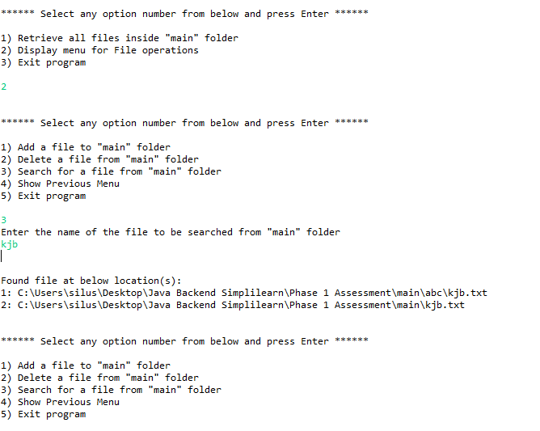

## **Step 5:** Writing a program in Java to perform the File operations as specified by user (**FileOperations.java**)

* Select your project and go to File -> New -> Class.
* Enter **FileOperations** in class name and click on “Finish.”
* **FileOperations** consists methods for -:
  1. Creating “main” folder in project if it’s not already present
  2. Displaying all files in “main” folder in ascending order and also with directory structure.
  3. Creating a file/folder as specified by user input.
  4. Search files as specified by user input in “main” folder and it’s subfolders.
  5. Deleting a file/folder from “main” folder

**Step 5.1:** Writing method to create “main” folder in project if it’s not present

**public** **static** **void** createMainFolderIfNotPresent(String folderName) {

File file = **new** File(folderName);

// If file doesn't exist, create the main folder

**if** (!file.exists()) {

file.mkdirs();

}

}

**Output:**

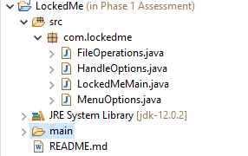

**Step 5.2:** Writing method to display all files in “main” folder in ascending order and also with directory structure. (“`--" represents a directory. “|--” represents a file.)

**public** **static** **void** displayAllFiles(String path) {

FileOperations.*createMainFolderIfNotPresent*("main");

// All required files and folders inside "main" folder relative to current

// folder

System.***out***.println("Displaying all files with directory structure in ascending order\n");

// listFilesInDirectory displays files along with folder structure

List<String> filesListNames = FileOperations.*listFilesInDirectory*(path, 0, **new** ArrayList<String>());

System.***out***.println("Displaying all files in ascending order\n");

Collections.*sort*(filesListNames);

filesListNames.stream().forEach(System.***out***::println);

}

**public** **static** List<String> listFilesInDirectory(String path, **int** indentationCount, List<String> fileListNames) {

File dir = **new** File(path);

File[] files = dir.listFiles();

List<File> filesList = Arrays.*asList*(files);

Collections.*sort*(filesList);

**if** (files != **null** && files.length > 0) {

**for** (File file : filesList) {

System.***out***.print(" ".repeat(indentationCount * 2));

**if** (file.isDirectory()) {

System.***out***.println("`-- " + file.getName());

// Recursively indent and display the files

fileListNames.add(file.getName());

*listFilesInDirectory*(file.getAbsolutePath(), indentationCount + 1, fileListNames);

} **else** {

System.***out***.println("|-- " + file.getName());

fileListNames.add(file.getName());

}

}

} **else** {

System.***out***.print(" ".repeat(indentationCount * 2));

System.***out***.println("|-- Empty Directory");

}

System.***out***.println();

**return** fileListNames;

}

**Output:**



**Step 5.3:** Writing method to create a file/folder as specified by user input.

**public** **static** **void** createFile(String fileToAdd, Scanner sc) {

FileOperations.*createMainFolderIfNotPresent*("main");

Path pathToFile = Paths.*get*("./main/" + fileToAdd);

**try** {

Files.*createDirectories*(pathToFile.getParent());

Files.*createFile*(pathToFile);

System.***out***.println(fileToAdd + " created successfully");

System.***out***.println("Would you like to add some content to the file? (Y/N)");

String choice = sc.next().toLowerCase();

sc.nextLine();

**if** (choice.equals("y")) {

System.***out***.println("\n\nInput content and press enter\n");

String content = sc.nextLine();

Files.*write*(pathToFile, content.getBytes());

System.***out***.println("\nContent written to file " + fileToAdd);

System.***out***.println("Content can be read using Notepad or Notepad++");

}

} **catch** (IOException e) {

System.***out***.println("Failed to create file " + fileToAdd);

System.***out***.println(e.getClass().getName());

}

}

**Output:**

**Folders are automatically created along with file**

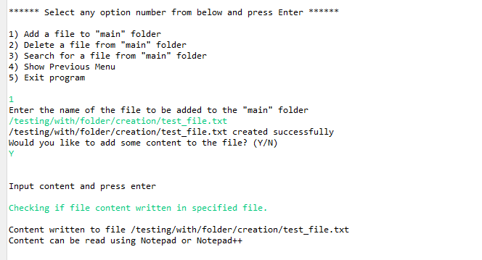

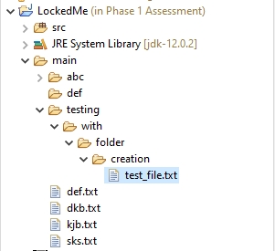

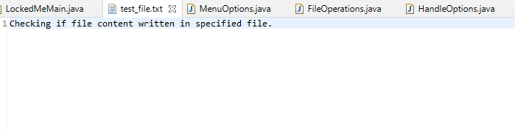

**Step 5.4:**  Writing method to search for all files as specified by user input in “main” folder and it’s subfolders.

**public** **static** List<String> displayFileLocations(String fileName, String path) {

List<String> fileListNames = **new** ArrayList<>();

FileOperations.*searchFileRecursively*(path, fileName, fileListNames);

**if** (fileListNames.isEmpty()) {

System.***out***.println("\n\n***** Couldn't find any file with given file name \"" + fileName + "\" *****\n\n");

} **else** {

System.***out***.println("\n\nFound file at below location(s):");

List<String> files = IntStream.*range*(0, fileListNames.size())

.mapToObj(index -> (index + 1) + ": " + fileListNames.get(index)).collect(Collectors.*toList*());

files.forEach(System.***out***::println);

}

**return** fileListNames;

}

**public** **static** **void** searchFileRecursively(String path, String fileName, List<String> fileListNames) {

File dir = **new** File(path);

File[] files = dir.listFiles();

List<File> filesList = Arrays.*asList*(files);

**if** (files != **null** && files.length > 0) {

**for** (File file : filesList) {

**if** (file.getName().startsWith(fileName)) {

fileListNames.add(file.getAbsolutePath());

}

// Need to search in directories separately to ensure all files of required

// fileName are searched

**if** (file.isDirectory()) {

*searchFileRecursively*(file.getAbsolutePath(), fileName, fileListNames);

}

}

}

}

**Output:**

**All files starting with the user input are displayed along with index**

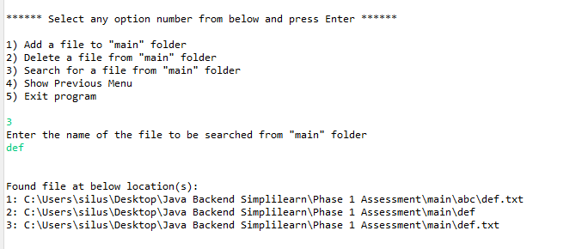

**Step 5.5:**  Writing method to delete file/folder specified by user input in “main” folder and it’s subfolders. It uses the searchFilesRecursively method and prompts user to specify which index to delete. If folder selected, all it’s child files and folder will be deleted recursively. If user wants to delete all the files specified after the search, they can input value 0.

**public** **static** **void** deleteFileRecursively(String path) {

File currFile = **new** File(path);

File[] files = currFile.listFiles();

**if** (files != **null** && files.length > 0) {

**for** (File file : files) {

String fileName = file.getName() + " at " + file.getParent();

**if** (file.isDirectory()) {

*deleteFileRecursively*(file.getAbsolutePath());

}

**if** (file.delete()) {

System.***out***.println(fileName + " deleted successfully");

} **else** {

System.***out***.println("Failed to delete " + fileName);

}

}

}

String currFileName = currFile.getName() + " at " + currFile.getParent();

**if** (currFile.delete()) {

System.***out***.println(currFileName + " deleted successfully");

} **else** {

System.***out***.println("Failed to delete " + currFileName);

}

}

**Output:**

To verify if file is deleted on Eclipse, right click on Project and click “Refresh”.

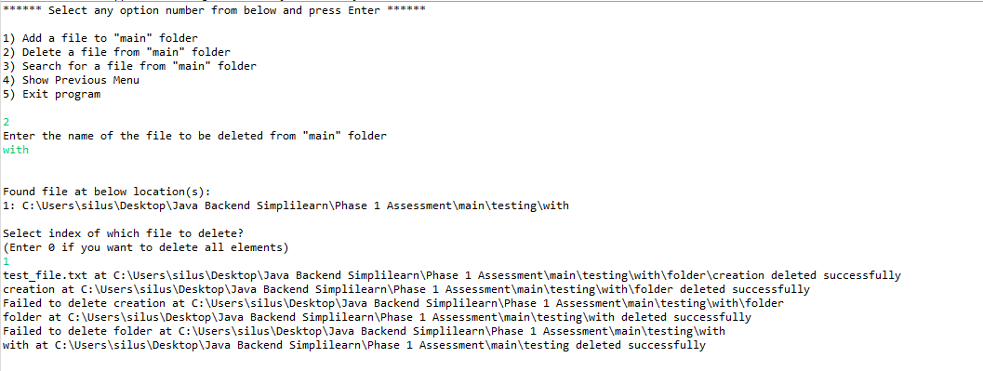

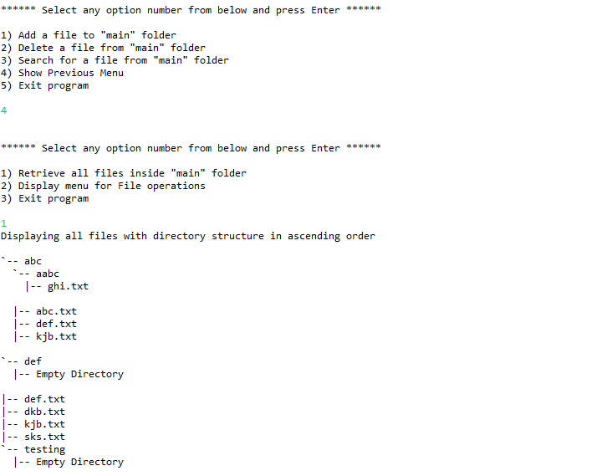

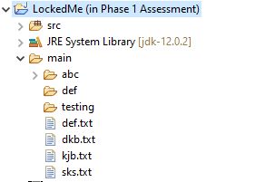

## **Step 6:** Pushing the code to GitHub repository

* Open your command prompt and navigate to the folder where you have created your files.

**cd <folder path>**

* Initialize repository using the following command:

**git init**

* Add all the files to your git repository using the following command:

**git add .**

* Commit the changes using the following command:

**git commit . -m <commit message>**

* Push the files to the folder you initially created using the following command:

**git push -u origin master**

## Unique Selling Points of the Application

1. The application is designed to keep on running and taking user inputs even after exceptions occur. To terminate the application, appropriate option needs to be selected.
2. The application can take any file/folder name as input. Even if the user wants to create nested folder structure, user can specify the relative path, and the application takes care of creating the required folder structure.
3. User is also provided the option to write content if they want into the newly created file.
4. The application doesn’t restrict user to specify the exact filename to search/delete file/folder. They can specify the starting input, and the program searches all files/folder starting with the value and displays it. The user is then provided the option to select all files or to select a specific index to delete.
5. The application also allows user to delete folders which are not empty.
6. The user is able to seamlessly switch between options or return to previous menu even after any required operation like adding, searching, deleting or retrieving of files is performed.
7. When the option to retrieve files in ascending order is selected, user is displayed with two options of viewing the files.
   1. Ascending order of folders first which have files sorted in them,
   2. Ascending order of all files and folders inside the “main” folder.
8. The application is designed with modularity in mind. Even if one wants to update the path, they can change it through the source code. Application has been developed keeping in mind that there should be very less “hardcoding” of data.

## Conclusions

Further enhancements to the application can be made which may include:

* Conditions to check if user is allowed to delete the file or add the file at the specific locations.
* Asking user to verify if they really want to delete the selected directory if it’s not empty.
* Retrieving files/folders by different criteria like Last Modified, Type, etc.
* Allowing user to append data to the file.